Table of Contents
SHORTCUTS FOR BASH TERMINAL 2
CDN’S 2
GIT COMMIT & PUSH TO THE CLOUD REPO: 2
SFDX CheatSheet: 2
SCRATCH ORGS 3
VIEW LOGS, RUN TESTS 3
Pure functions to work with arrays the best way (Vanilla & react) 4
Array Methods 4
Methods to use for arrays: map() , filter(), reduce(), forEach() 5
REACT CHEAT SHEET 6
1 - React Skeleton 6
SHORTCUTS WITH [ES7 React/Redux/GraphQL/React-Native snippets] pluguin for VSCode 7
Basic Methods 7
React 8
React props: 9
Default props (Components can specify default values for missing props) 10
React STATE 11
Changing STATE 11
State downward data flow 12
Modify state the right way: the safest way to update state is to make a copy of it, and then call this.setState with the new copy. 12
Passing functions to child components: 13
React forms 14
Passing Data Up to a Parent Component 14
React Lifecycle 15
These are the Reactjs lifecycle component events and when they occur: 16
React Router 18
Example of basic routing 18
Create & remove things from state the react way (Never override the state, always make a copy of it and then reassign it!) 19

SHORTCUTS FOR BASH TERMINAL

- mkdir [Make a new directory]
- touch [Make a new empty file]
- cp [Copy a file]
- mv [Move a file]
- rm [Remove a file or directory (learn about the -r option)]
- less [Show the contents of a file in a scrolling buffer]

CDN’S
<script src="https://kit.fontawesome.com/afb679a6fd.js"></script> [FONT AWESOME]
or just do npm install –save-dev @fortawesome/fontawesome-free and then:
on index.js import "@fortawesome/fontawesome-free/css/all.css";

GIT COMMIT & PUSH TO THE CLOUD REPO:
git branch -a (TO LIST ALL BRANCHES)
git fetch
git add .
git commit —amend—no-edit
git commit -m “MENSAJE” —no-verify
git push —set-upstream origin NOMBREBRANCH
git log —start
git checkout NOMBREBRANCH [CHANGE BRACH ]
git branch [LIST BRANCHES

SFDX CheatSheet:
CREATE CLASS, AURA, LWC, TRIGGER, COMPONENT
sfdx force:lightning:app:create -n myAuraapp
sfdx force:lightning:component:create --type aura -n myAuraComponent
sfdx force:apex:class:create -n myclass
sfdx force:apex:trigger:create -n mytrigger -s Account -e 'before insert, after upsert' -d <app-dir>/main/default/triggers
sfdx force:lightning:component:create --type lwc -n myLightningWebComponent

SCRATCH ORGS
sfdx force:auth:web:login -d -a DevHub
sfdx force:org:create -s -f -a sam --setdefaultusername
sfdx force:source:push -f
sfdx force:org:open -r

VIEW LOGS, RUN TESTS

sfdx force:apex:test:run
sfdx force:apex:log:list
sfdx force:apex:log:get --logid HEREGOESTHEID
sfdx force:limits:api:display -u DevHub (VIEW THE SCRATCH LIMITS)
sfdx force:source:status (CHANGES BETWEEN SCRATCH AND CODE)

BITBUCKET KEY 4329ba5f1a2985ddb12229e82a0c825d3c44a7c1

Pure functions to work with arrays the best way (Vanilla & react)

Array Methods
Once you have created arrays, there are a few things you can do with them:
concat() — Join several arrays into one
indexOf() — Returns the first position at which a given element appears in an array
join() — Combine elements of an array into a single string and return the string
lastIndexOf() — Gives the last position at which a given element appears in an array
pop() — Removes the last element of an array
push() — Add a new element at the end
reverse() — Sort elements in a descending order
shift() — Remove the first element of an array
slice() — Pulls a copy of a portion of an array into a new array
sort() — Sorts elements alphabetically
splice() — Adds elements in a specified way and position
toString() — Converts elements to strings
unshift() —Adds a new element to the beginning
valueOf() — Returns the primitive value of the specified object

Methods to use for arrays: map() , filter(), reduce(), forEach()
MAP()  Use it when: You want to translate/map all elements in an array to another set of values.  Example: convert Fahrenheit temps to Celsius.  var fahrenheit = [0, 32, 45, 50, 75, 80, 99, 120];  var celcius = fahrenheit.map(function(elem) {  return Math.round((elem - 32) * 5 / 9);  });  // ES6  // fahrenheit.map(elem => Math.round((elem - 32) * 5 / 9));  celcius // [-18, 0, 7, 10, 24, 27, 37, 49] | FILTER()  Use it when: You want to remove unwanted elements based on a condition.  Example: remove duplicate elements from an array.  var uniqueArray = array.filter(function(elem, index, array) {  return array.indexOf(elem) === index;  }  );  // ES6  // array.filter((elem, index, arr) => arr.indexOf(elem) === index);
REDUCE()
Use it when: You want to find a cumulative or concatenated value based on elements across the array.

Example: Sum up orbital rocket launches in 2014.
var rockets = [
{ country:'Russia', launches:32 },
{ country:'US', launches:23 },
{ country:'China', launches:16 },
{ country:'Europe(ESA)', launches:7 },
{ country:'India', launches:4 },
{ country:'Japan', launches:3 }
];
var sum = rockets.reduce(function(prevVal, elem) {
return prevVal + elem.launches;
}, 0);
// ES6
// rockets.reduce((prevVal, elem) => prevVal + elem.launches, 0);

sum // 85

REACT CHEAT SHEET

npx create-react-app nombre-app
cd nombre-app
npm start

*ID for iterators
import uuid from 'uuid/v4';
Usarla ==== uuid()

1 - React Skeleton
1- Imports:
import React, { Component } from 'react'
import XX from './XX'; [llamarla como “XX” ]
import './CLASE.css'; [Importar CSS si es necesario y crearlo en el mismo directorio]
2- Definir clase (Si es un componente de clase y como estructurarla):

export class NombreClase extends Component { //clase arranca aqui...}
constructor [con props y state, lugar donde se bindean los metodos a this]
metodos si es necesario [Hay que bindearlos al constructor asi: ‘this.metodo = this.metodo.bind(this);
render() [Es el metodo para hacer render de lo que queramos en el componente]
return: muy importante, aqui se retorna lo que se decea renderar del componente.
El return puede admitir solo un elemento por lo tanto se lo suele encerrar entre “()” y englobar todo en un div o form, o lo que se necesite (esto si se van a devolver multiples cosas.
export de ser necesario se exporta parte de la clase o toda la clase para ser usada en otro componente, se realiza de la siguiente manera: export default NombreClase

SHORTCUTS WITH [ES7 React/Redux/GraphQL/React-Native snippets] pluguin for VSCode

Basic Methods
Prefix | Method
rce→ | import React, { Component } from 'react'  export class FileName extends Component {  render() {  return <div>$2</div>  }  }  export default $1
imp→ | import moduleName from 'module'
imn→ | import 'module'
ime→ | import * as alias from 'module'
ima→ | import { originalName as aliasName} from 'module'
exp→ | export default moduleName
exd→ | export { destructuredModule } from 'module'
exa→ | export { originalName as aliasName} from 'module'
enf→ | export const functionName = (params) => { }
edf→ | export default (params) => { }
met→ | methodName = (params) => { }
fre→ | arrayName.forEach(element => { }
fof→ | for(let itemName of objectName { }
fin→ | for(let itemName in objectName { }
anfn→ | (params) => { }
nfn→ | const functionName = (params) => { }
sti→ | setInterval(() => { }, intervalTime
sto→ | setTimeout(() => { }, delayTime
prom→ | return new Promise((resolve, reject) => { }
cmmb→ | comment block

React
Prefix | Method
imr→ | import React from 'react'
imrd→ | import ReactDOM from 'react-dom'
imrc→ | import React, { Component } from 'react'
imrcp→ | import React, { Component } from 'react' & import PropTypes from 'prop-types'
imrpc→ | import React, { PureComponent } from 'react'
imrpcp→ | import React, { PureComponent } from 'react' & import PropTypes from 'prop-types'
imrm→ | import React, { memo } from 'react'
imrmp→ | import React, { memo } from 'react' & import PropTypes from 'prop-types'
impt→ | import PropTypes from 'prop-types'
imrr→ | import { BrowserRouter as Router, Route, Link } from 'react-router-dom'
redux→ | import { connect } from 'react-redux'
rconst→ | constructor(props) with this.state
rconc→ | constructor(props, context) with this.state
est→ | this.state = { }
cwm→ | componentWillMount = () => { } DEPRECATED!!!
cdm→ | componentDidMount = () => { }
scu→ | shouldComponentUpdate = (nextProps, nextState) => { }
cdup→ | componentDidUpdate = (prevProps, prevState) => { }
cwun→ | componentWillUnmount = () => { }
gdsfp→ | static getDerivedStateFromProps(nextProps, prevState) { }
gsbu→ | getSnapshotBeforeUpdate = (prevProps, prevState) => { }
ren→ | render() { return( ) }
sst→ | this.setState({ })
ssf→ | this.setState((state, props) => return { })
props→ | this.props.propName
state→ | this.state.stateName
rcontext→ | const ${1:contextName} = React.createContext()
cref→ | this.${1:refName}Ref = React.createRef()
fref→ | const ref = React.createRef()
bnd→ | this.methodName = this.methodName.bind(this)

React props:

Looping in JSX
demo/friends/Friend.js  class Friend extends React.Component {  render() {  const { name, hobbies } = this.props;  return (  <div>  <h1>{name}</h1>  <ul>  {hobbies.map(h => <li>{h}</li>)}  </ul>  </div>  );}} | demo/friends/index.js  ReactDOM.render(  <div>  <Friend name="Jessica" hobbies={["Tea", "Frisbee"]} />  <Friend name="Jake" hobbies={["Chess", "Cats"]} />  </div>,  document.getElementById("root")  );

Props
Properties are for configuring your component
Properties are immutable
Get to properties inside class with this.props.propertyName
To embed a JS expression I can just use curly braces ‘{}’
User name="Jane" salary={ 100000 }
hobbies={ ["bridge", "reading", "tea"] } />

How to use them
Machine.js  class Machine extends React.Component {  render() {  const { s1, s2, s3 } = this.props;  const winner = (s1 === s2) && (s2 === s3);  return (  <div className="Machine">  <b>{s1}</b> <b>{s2}</b> <b>{s3}</b>  <p>You {winner ? "win!" : "lose!"}</p>  </div>  );}} | Imdex.js  ReactDOM.render(  <Machine s1="🍇" s2="🍇" s3="🍇" />,  document.getElementById("root")  );

Default props (Components can specify default values for missing props)
Hello.js  class Hello extends React.Component {  static defaultProps = {  from: "Joel",  };  render() {  return <p>Hi {this.props.to} from {this.props.from}</p>;  }  } | Index.js  ReactDOM.render(  <div>  <Hello to="Students" from="Elie" />  <Hello to="World" />  </div>,  document.getElementById("root")  );

React STATE
In React, state is an instance attribute on a component.
Always have an initial state  class ClickCount extends Component {  constructor(props) {  super(props);  this.state = {  numClicks: 0 // start at zero clicks  };}} | I can also use this synthax w/o a constructor  class ClickCount extends Component {  state = {variable : 0};  //…  }

Changing STATE

this.setState() is the built-in React method of changing a component’s state.
Eg: this.setState ({ name: “guille”, lName: “Elgorriaga” }
Can call in any instance method except the constructor
Takes an object describing the state changes
Patches state object — keys that you didn’t specify don’t change
Asynchronous!
The component state will eventually update.
React controls when the state will actually change, for performance reasons.
Components re-render when their state changes
*Always important to bind all the methos to the constructor .bind(this);
Example

class ClickRando extends Component {
constructor(props) {
super(props);
this.state = { num: 0 };
this.handleClick = this.handleClick.bind(this);
}
setRandom() {
this.setState({
num: Math.floor(Math.random() * this.props.maxNum)
});
}
handleClick(evt) {
this.setRandom();
}
render() {
return (
<button onClick={this.handleClick}>
Click Rando: {this.state.num}
</button>
);}}

State downward data flow

A common pattern we will see over and over again is a stateful (“smart”) parent component passing down its state values as props to stateless (“dumb”) child components.
This idea is generalized in React as “downward data flow”. It means that components get simpler as you go down the component hierarchy, and parents tend to be more stateful than their children.

class CounterParent extends Component {
constructor(props) {
super(props);
this.state = {count: 5};
}
render() {
// passing down parent state as a prop to the child
return (
<div>
<CounterChild count={this.state.count} />
</div>
);}}

Modify state the right way: the safest way to update state is to make a copy of it, and then call this.setState with the new copy.
completeTodo(id) {

// Array.prototype.map returns a new array
const newTodos = this.state.todos.map(todo => {
if (todo.id === id) {
// make a copy of the todo object with done -> true
return { ...todo, done: true };
}
return todo; // old todos can pass through
});

this.setState({
todos: newTodos // setState to the new array
});
}

In order to do that, pure functions are the best, such as .map .filter .reduce and … (spread op)

Passing functions to child components:
The idea: children are often not stateful, but need to tell parents to change state
How we send data “back up” to a parent component
How data flows:
A parent component defines a function
The function is passed as a prop to a child component
The child component invokes the prop
The parent function is called, usually setting new state
The parent component is re-rendered along with its children
PARENT  class NumList extends Component {  constructor(props) {  super(props);  this.state = { nums: [1, 2, 3, 4, 5] };  this.remove = this.remove.bind(this);  }  remove(num) {  this.setState(st => ({  nums: st.nums.filter(n => n !== num)}))  }  render() {  let nums = this.state.nums.map((n, idx) => (  <NumberItem  value={n}  key={idx}  remove={this.remove} />  ));  return <ul>{nums}</ul>;  }  } | CHILD  class NumberItem extends Component {  constructor(props) {  super(props);  this.handleRemove =  this.handleRemove.bind(this);  }  handleRemove() {  this.props.remove(this.props.value);  }  render(){  return(  <li>  {this.props.value}  <button  onClick={this.handleRemove}>  X  </button>  </li>  )}}

React forms
The idea is that every single input is in sync with react state, here is an example

class NameForm extends Component { // …
this.state = { firstName: "", lastName:"" };
handleChange(evt) {
this.setState({ [evt.target.name]: evt.target.value });
}

render() {
return (
<form onSubmit={this.handleSubmit}>

<label htmlFor="firstName">First:</label>
<input id="firstName" name="firstName"
value={this.state.firstName}
onChange={this.handleChange} />

<label htmlFor="lastName">Last:</label>
<input id="lastName" name="lastName"
value={this.state.lastName}
onChange={this.handleChange} />
<button>Add a new person!</button>

</form>
);}}

Passing Data Up to a Parent Component
class ShoppingList extends Component {  addItem(item) {  let newItem = { ...item, id: uuid() };  this.setState(state => ({  items: [...state.items, newItem]  })));}  render() {  return(<div>  <NewListForm addItem={this.addItem}/>  {this.renderItems()}  </div>  );}}  this.setState(state => ({  items: [...state.items, newItem]  }));  } | class NewListItemForm extends Component {  handleSubmit(evt) {  evt.preventDefault();  this.props.addItem(this.state);  this.setState({ name: "", qty: 0 });  }  }

React Lifecycle

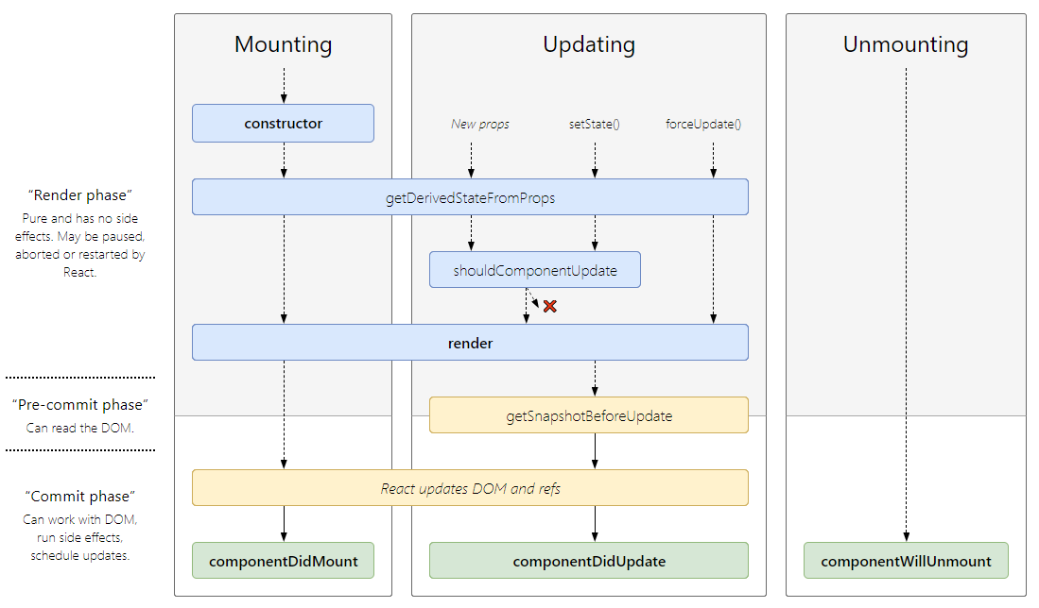
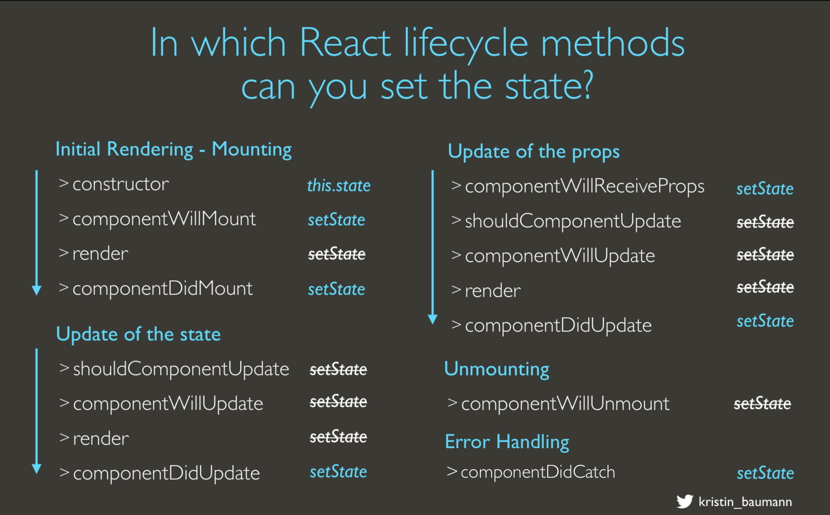

These are the Reactjs lifecycle component events and when they occur:

- componentWillMount : Runs before initial render. Set initial state here
- componentDidMount : Runs immediately after render. This is when the DOM exists, excelent for fetching from APIs
- componentWillReceiveProps: Runs when the component is receiving new properties. This is not called on initial render. You can set state before render here.
- shouldComponentUpdate : Runs immediately before render or when new props and/or state is being received by your component. You could increase performance by preventing a render if not necessary here.
- componentWillUpdate : Runs right before rendering when new props or state are being received. Not called on initial render. You cannot call setState in this function.
- componentDidUpdate : Runs when the components updates are flushed to the DOM. You can interact with the component in the DOM here.
- componentWillUnmount : runs just before the component is unmounted from the DOM. Great place to clean up anything.

CDN example with Axios (npm install axios)

import axios from 'axios';
//…
componentDidMount() {
axios.get("https://api.github.com/zen").then(response => {
setTimeout(
function () {
this.setState({ quote: response.data, isLoaded: true });

}.bind(this),3000);
});
}

React Router
npm install react-router-dom
import { BrowserRouter as Router, Route, Link } from "react-router-dom"; /import router in the component.
https://reacttraining.com/react-router/web/guides/quick-start

Example of basic routing

import React, { Component } from 'react'
import './App.css';
import { BrowserRouter as Router, Route, NavLink, Switch } from 'react-router-dom'

const Dog = (props) => <h1> I am a dog {props.kind} of {props.age} Y/O</h1>; //functional component
const Contact = () => <h1> Dont contact us, ever</h1>; //functional component
const About = () => <h1>About us</h1>; //functional component
const DogHater = () => <h1> I hate dogs</h1>; //functional component

export class App extends Component {
render() {
return (
<div className="App">
<nav className= "App-nav">
<NavLink exact activeClassName="active-link" to='/'>about</NavLink>
<NavLink exact activeClassName="active-link" to='/dog'>dog</NavLink>
<NavLink exact activeClassName="active-link" to='/contact'>contact</NavLink>
<NavLink exact activeClassName="active-link" to='/dog/hater'>dhater</NavLink>
</nav>
<Switch>
<Route exact path='/' render={About} />
<Route exact path='/dog' render={()=><Dog kind='caniche' age={10}/>} />
<Route exact path='/dog/hater' render={DogHater} />
<Route exact path='/contact' render={Contact} />
</Switch>
</div>
);}}

export default App

Create & remove things from state the react way (Never override the state, always make a copy of it and then reassign it!)

addItem(item) {  let newItem = { ...item, id: uuid()}  this.setState(state => ({  items: [...state.items, newItem]  }));  } | removeItem(id) {  this.setState({  todos: this.state.todos.filter(todo => todo.id !== id)  });  }

TIPS
To avoid using this.props.x we can use const {prop1, prop2, prop3)=this.props; and then call them from their name.
We can just define state as state={………};
If I don't wanna bind every function I can define it as an arrow function f= ()=>{ ………...}

